**MongoDB Practice – Atomicity**

test> use mongodb

switched to db mongodb

mongodb> db.students.find()

mongodb> show dbs

Cricket 60.00 KiB

School 72.00 KiB

admin 40.00 KiB

config 72.00 KiB

local 72.00 KiB

mongodb 40.00 KiB

test 64.00 KiB

mongodb> use School

switched to db School

School> db.students.find()

[

{

_id: ObjectId('687f1a6a9c3738da89eec4a9'),

name: 'Duns',

score: 495

},

{_id: ObjectId('687f1ba39c3738da89eec4aa'),

name: 'Dany',

score: 150}]

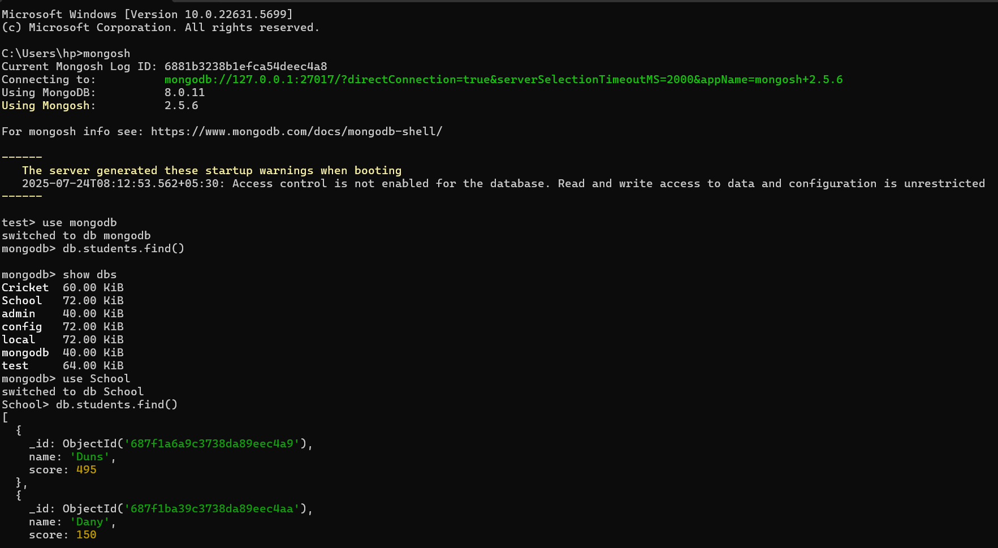

School> db.students.updateOne({ name: "Duns"},{ $set: { name: "Allen" }})

{

acknowledged: true,

insertedId: null,

matchedCount: 1,

modifiedCount: 1,

upsertedCount: 0

}

School> db.students.find()

[

{

_id: ObjectId('687f1a6a9c3738da89eec4a9'),

name: 'Allen',

score: 495

},

{

_id: ObjectId('687f1ba39c3738da89eec4aa'),

name: 'Dany',

score: 150

}

]

School> db.students.updateOne({ name: "Duns"},{ $set: { score: 95 }})

{

acknowledged: true,

insertedId: null,

matchedCount: 0,

modifiedCount: 0,

upsertedCount: 0

}

School> db.students.updateOne({ name: "Dany"},{ $set: { score: 80 }})

{

acknowledged: true,

insertedId: null,

matchedCount: 1,

modifiedCount: 1,

upsertedCount: 0

}

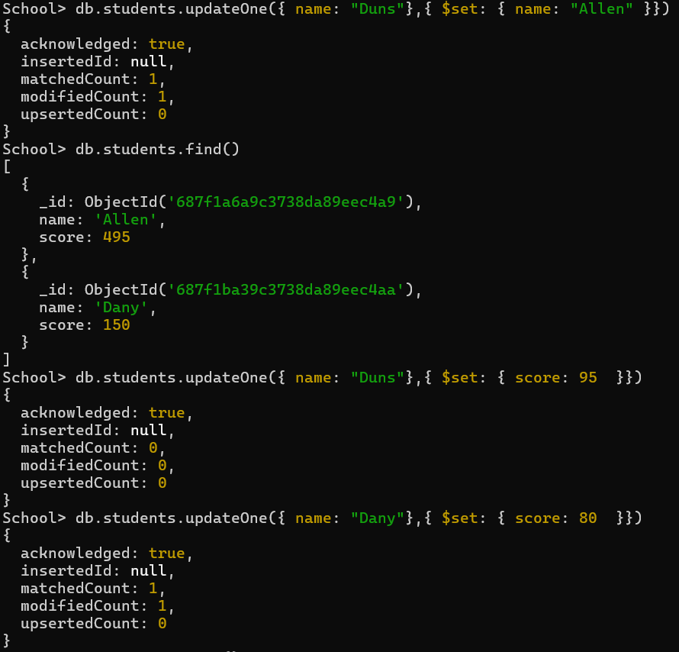

School> db.students.find()

[

{

_id: ObjectId('687f1a6a9c3738da89eec4a9'),

name: 'Allen',

score: 495

},

{

_id: ObjectId('687f1ba39c3738da89eec4aa'),

name: 'Dany',

score: 80

}

]

School> db.students.updateOne({ name: "Duns"},{ $inc: { score: 70 }})

{

acknowledged: true,

insertedId: null,

matchedCount: 0,

modifiedCount: 0,

upsertedCount: 0

}

School> db.students.insertOne({ name: "Duns"},{ $set: { score: 85 }})

{

acknowledged: true,

insertedId: ObjectId('6881ba608b1efca54deec4a9')

}

School> db.students.insertOne({ name: "Duns"},{ $inc: { score: 95 }})

{

acknowledged: true,

insertedId: ObjectId('6881ba808b1efca54deec4aa')}

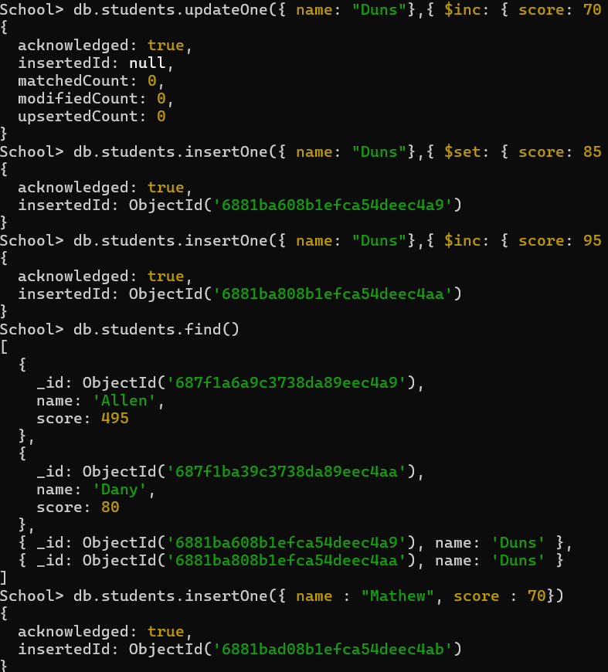

School> db.students.find()

[

{

_id: ObjectId('687f1a6a9c3738da89eec4a9'),

name: 'Allen',

score: 495

},

{

_id: ObjectId('687f1ba39c3738da89eec4aa'),

name: 'Dany',

score: 80

},

{ _id: ObjectId('6881ba608b1efca54deec4a9'), name: 'Duns' },

{ _id: ObjectId('6881ba808b1efca54deec4aa'), name: 'Duns' }

]

School> db.students.insertOne({ name : "Mathew", score : 70})

{

acknowledged: true,

insertedId: ObjectId('6881bad08b1efca54deec4ab')

}

School> db.students.insertOne({ name : "Mathew"},{$inc:{ score : 80}})

{

acknowledged: true,

insertedId: ObjectId('6881bb1f8b1efca54deec4ac')

}

School> db.students.find()

[

{

_id: ObjectId('687f1a6a9c3738da89eec4a9'),

name: 'Allen',

score: 495

},

{

_id: ObjectId('687f1ba39c3738da89eec4aa'),

name: 'Dany',

score: 80

},

{ _id: ObjectId('6881ba608b1efca54deec4a9'), name: 'Duns' },

{ _id: ObjectId('6881ba808b1efca54deec4aa'), name: 'Duns' },

{

_id: ObjectId('6881bad08b1efca54deec4ab'),

name: 'Mathew',

score: 70

},

{ _id: ObjectId('6881bb1f8b1efca54deec4ac'), name: 'Mathew' }

]

School> db.students.deleteOne({ name : "Duns"})

{ acknowledged: true, deletedCount: 1 }

School> db.students.deleteOne({ name : "Duns"})

{ acknowledged: true, deletedCount: 1 }

School> db.students.find()

[

{

_id: ObjectId('687f1a6a9c3738da89eec4a9'),

name: 'Allen',

score: 495

},

{

_id: ObjectId('687f1ba39c3738da89eec4aa'),

name: 'Dany',

score: 80

},

{

_id: ObjectId('6881bad08b1efca54deec4ab'),

name: 'Mathew',

score: 70

},

{ _id: ObjectId('6881bb1f8b1efca54deec4ac'), name: 'Mathew' }

]

School> db.students.updateOne({ name : "Mathew"},{$inc:{ score : 90}})

{

acknowledged: true,

insertedId: null,

matchedCount: 1,

modifiedCount: 1,

upsertedCount: 0

}

School> db.students.updateOne({ name : "Dany"},{$inc:{ score : 100}})

{

acknowledged: true,

insertedId: null,

matchedCount: 1,

modifiedCount: 1,

upsertedCount: 0

}

School> db.students.updateOne({ name : "Dany"},{$inc:{ score : 150}})

{

acknowledged: true,

insertedId: null,

matchedCount: 1,

modifiedCount: 1,

upsertedCount: 0

}

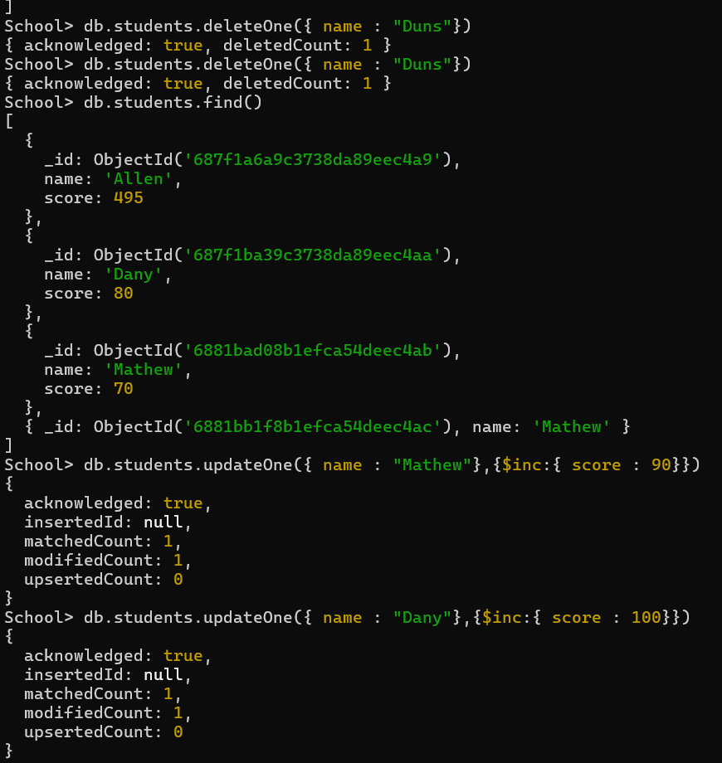

School> db.students.find()

[

{

_id: ObjectId('687f1a6a9c3738da89eec4a9'),

name: 'Allen',

score: 495

},

{

_id: ObjectId('687f1ba39c3738da89eec4aa'),

name: 'Dany',

score: 330

},

{

_id: ObjectId('6881bad08b1efca54deec4ab'),

name: 'Mathew',

score: 160

},

{ _id: ObjectId('6881bb1f8b1efca54deec4ac'), name: 'Mathew' }

]

School> db.students.deleteOne({ name : "Mathew"})

{ acknowledged: true, deletedCount: 1 }

School> db.students.find()

[

{

_id: ObjectId('687f1a6a9c3738da89eec4a9'),

name: 'Allen',

score: 495

},

{

_id: ObjectId('687f1ba39c3738da89eec4aa'),

name: 'Dany',

score: 330

},

{ _id: ObjectId('6881bb1f8b1efca54deec4ac'), name: 'Mathew' }

]

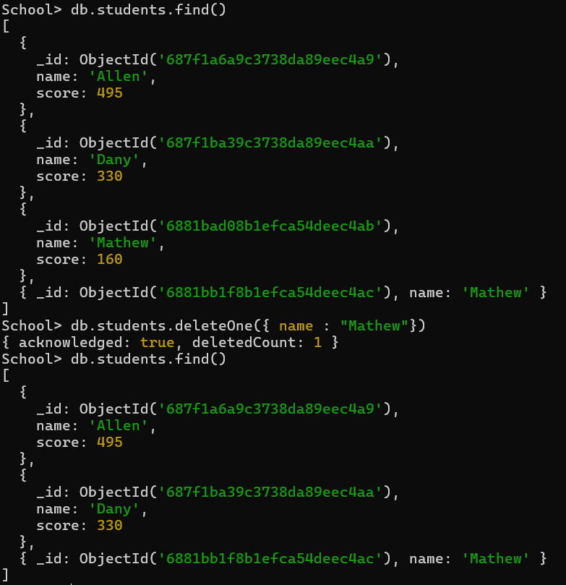

**Submitted by**

Siva Balan T